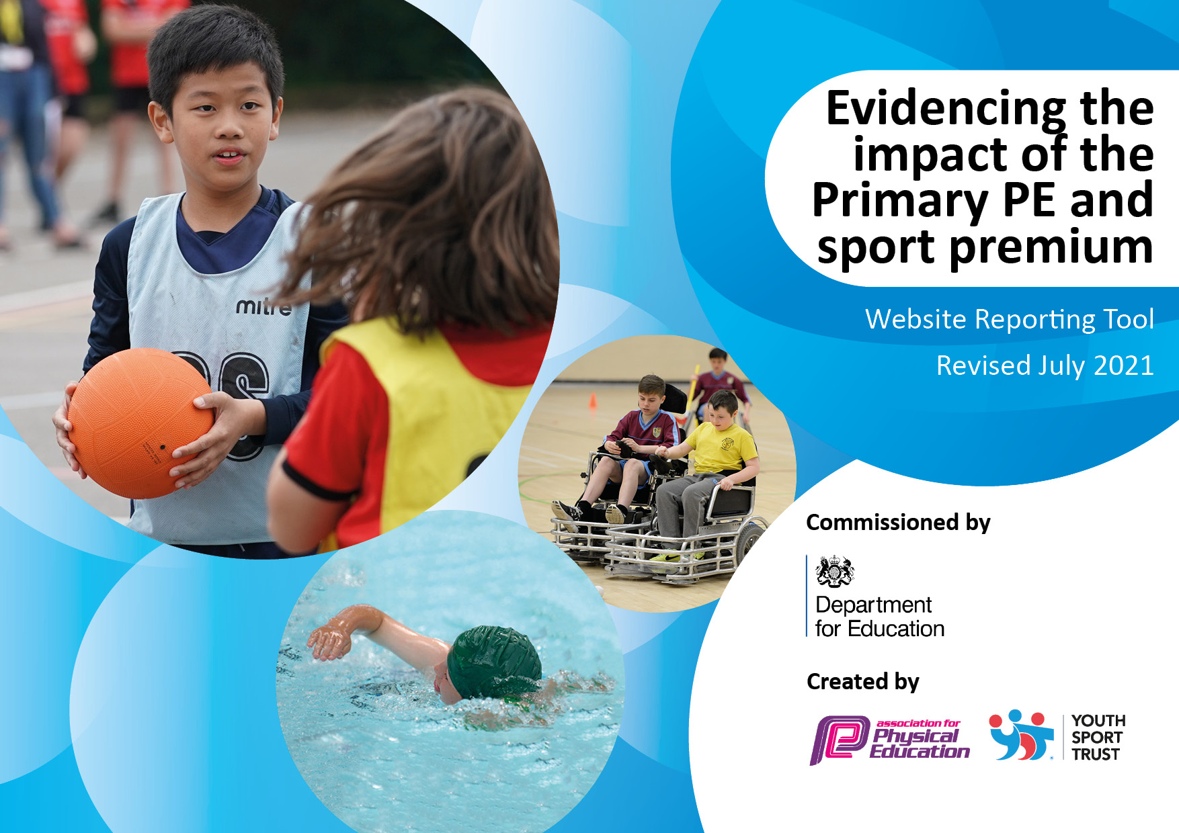
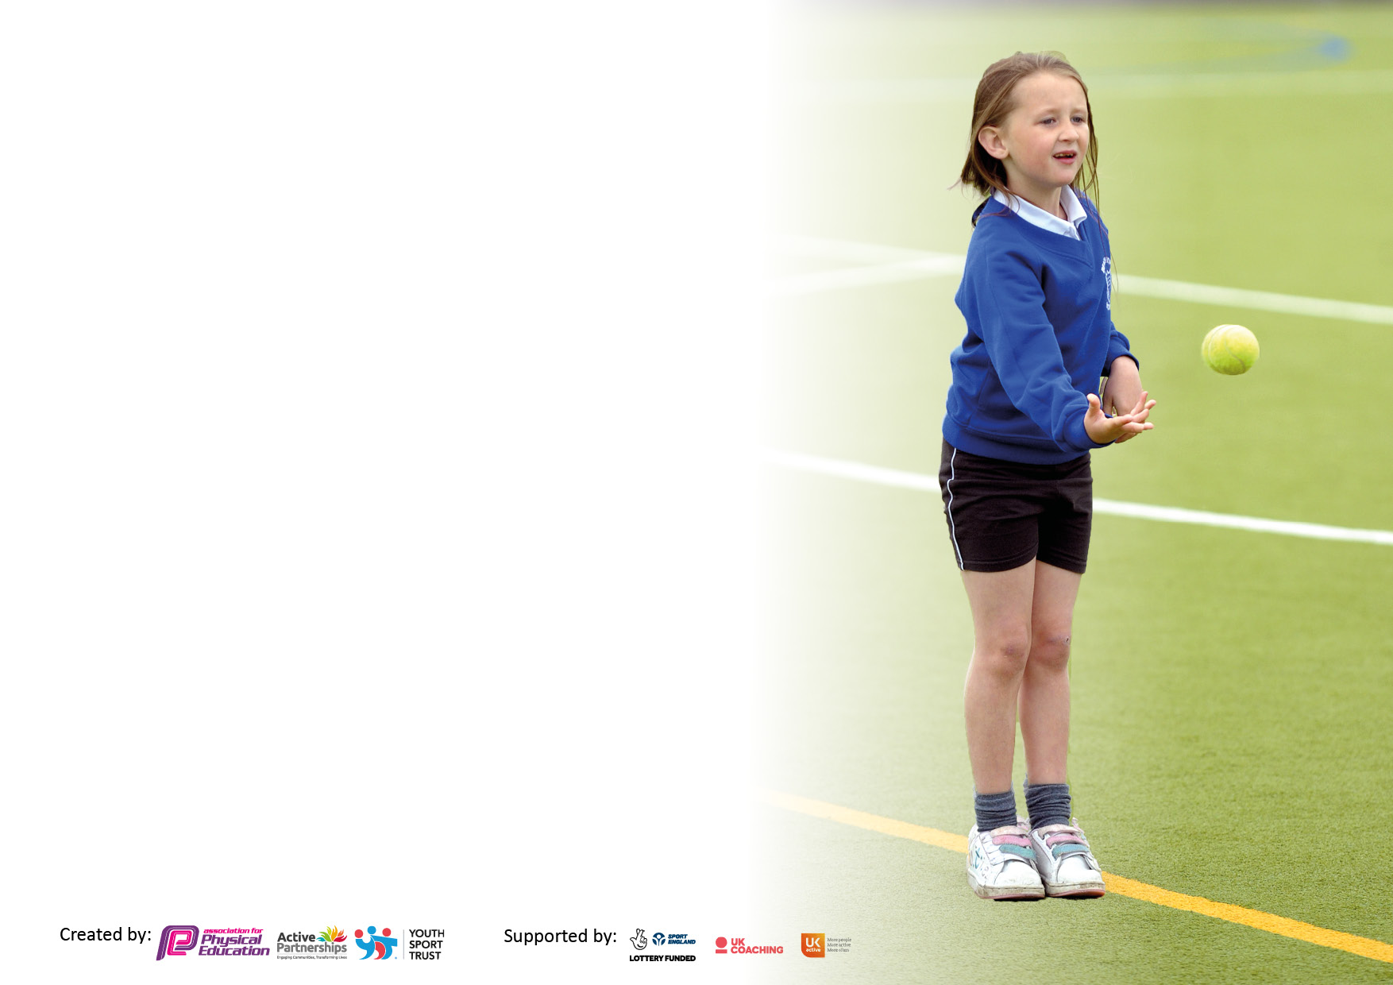

It is important that your grant is used effectively and based on school need. The Education Inspection Framework makes clear there will be a focus on ‘whether leaders and those responsible for governors all understand their respective roles and perform these in a way that enhances the effectiveness of the school’.

Under the Quality of Education Ofsted inspectors consider:
Intent - Curriculum design, coverage and appropriateness
Implementation - Curriculum delivery, Teaching (pedagogy) and Assessment
Impact - Attainment and progress

To assist schools with common transferable language this template has been developed to utilise the same three headings which should make your plans easily transferable between working documents.

Schools must use the funding to make additional and sustainable improvements to the quality of Physical Education, School Sport and Physical Activity (PESSPA) they offer. This means that you should use the Primary PE and sport premium to:

- Develop or add to the PESSPA activities that your school already offer
- Build capacity and capability within the school to ensure that improvements made now will benefit pupils joining the school in future years
- The Primary PE and sport premium should not be used to fund capital spend projects; the school’s budget should fund these.

Pleasevisitgov.ukfortherevisedDfEguidanceincludingthe5keyindicatorsacrosswhichschoolsshoulddemonstrate animprovement.Thisdocumentwillhelpyoutoreviewyourprovisionandtoreportyourspend.DfEencouragesschools to use this template as an effective way of meeting the reporting requirements of the Primary PE and sport premium.

We recommend you start by reflecting on the impact of current provision and reviewing the previous spend.

Schools are required to publish details of how they spend this funding, including any under-spend as well as on the impact it has on pupils’ PE and sport participation and attainment. All funding must be spent by 31st July 2022.

We recommend regularly updating the table and publishing it on your website throughout the year. This evidences your ongoing self-evaluation of how you are using the funding to secure maximum, sustainable impact. Final copy must be posted on your website by the end of the academic year and no later than the 31st July 2021. To see an example of how to complete the table please click HERE.
Created by: Supported by:

Details with regard to funding
Please complete the table below.

Total amount allocated for 2020/21 | £17990
How much (if any) do you intend to carry over from this total fund into 2021/22? | £9,264
Total amount allocated for 2021/22 | £18040
Total amount of funding for 2021/22. To be spent and reported on by 31st July 2022. | £27304 (total amount spent £28548)
Swimming Data
Please report on your Swimming Data below.

Meeting national curriculum requirements for swimming and water safety.

N.B. Complete this section to your best ability. For example you might have practised safe self-rescue techniques on dry land which you can then transfer to the pool when school swimming restarts.
Due to exceptional circumstances priority should be given to ensuring that pupils can perform safe self rescue even if they do not fully meet the first two requirements of the NC programme of study
What percentage of your current Year 6 cohort swim competently, confidently and proficiently over a distance of at least 25 metres?  N.B. Even though your pupils may swim in another year please report on their attainment on leaving primary school at the end of the summer term 2020.  Please see note above | 83%
What percentage of your current Year 6 cohort use a range of strokes effectively [for example, front crawl, backstroke and breaststroke]?  Please see note above | 63%
What percentage of your current Year 6 cohort perform safe self-rescue in different water-based situations? | 57%
Schools can choose to use the Primary PE and sport premium to provide additional provision for swimming but this must be for activity over and above the national curriculum requirements. Have you used it in this way? | Yes/No

Action Plan and Budget Tracking
Capture your intended annual spend against the 5 key indicators. Clarify the success criteria and evidence of impact that you intend to measure to evaluate for pupils today and for the future.

Academic Year: 2020/21 | Total fund allocated: | Date Updated:
Key indicator 1: The engagement of all pupils in regular physical activity – Chief Medical Officers guidelines recommend that primary school pupils undertake at least 30 minutes of physical activity a day in school |  |  |  | Percentage of total allocation:
Intent | Implementation |  | Impact
Your school focus should be clear what you want the pupils to know and be able to do and about  what they need to learn and to  consolidate through practice: | Make sure your actions to achieve are linked to your intentions: | Funding allocated: | Evidence of impact: what do pupils now know and what can they now do? What has changed?: | Sustainability and suggested next steps:
-To continue to promote daily running for children in school and overall fitness for Children  -Pinpoint specific groups of children who need to access intervention for their physical education through our coaching package.  -Ensure our high quality PE and school sport offer develops competent and confident movers with the aim of inspiring lifelong participation in physical activity.  - Bikeability provided for whole school to increase bike confidence and Year 6 to take part in Bikeability award  - Balance bikes for EYFS to improve core stability and bike riding confidence | - Through PE lessons and sport, ensure our children understand the role of movement in the development of their own physical literacy, fitness and well-being.  - Build links with local community sports clubs through our SGO.  - Purchase Resources  - Encourage use of initiatives such as the ‘Daily Mile’ in ALL year groups  -Encourage EYFS to use track and outdoor areas  - Daily mile track | £ 9,264 (towards the running track)  £4900 (GOVELO)  Balance bikes and helmets £400  PE scheme of work £1000  Additional intervention group for PE- £750 | - Positive attitudes to health and well-being  - Pupil concentration, commitment, self-esteem and behaviour enhanced for sports ambassadors  - Children enjoy PE lessons with both coaches and teachers  - Positive behaviour and a sense of fair play enhanced  - Pupils activity at lunch and break increased  - Children taking part in daily additional activities such as ‘The Daily Mile’ regularly at lunch times and afternoon brain breaks  - children across the school more active on a daily basis and enjoy being active  - Children have more room on the playground at break times as y3/4 and y5/6 have separate play times.  - Rota system at lunchtime ensures that children get to take part in lots of different activities  Evidence -  - Curriculum map  - PE policy  - Registers of participation  - PE app assessments  - Pupil interviews  - Winning good sportsmanship awards at comps | - Ensure assessments are happening half termly on PE app  -Encourage daily mile competitions etc for sports crew to run  -Invest in more playtime equipment  -Invest in more outdoor EYFS learning equipment
Key indicator 2: The profile of PESSPA being raised across the school as a tool for whole school improvement |  |  |  | Percentage of total allocation:
Intent | Implementation |  | Impact
Your school focus should be clear what you want the pupils to know and be able to do and about  what they need to learn and to  consolidate through practice: | Make sure your actions to achieve are linked to your intentions: | Funding allocated: | Evidence of impact: what do pupils now know and what can they now do? What has changed?: | Sustainability and suggested next steps:
- Use PE and sport to enable the development of life skills that are transferred to other curriculum areas, wider school and beyond.  -Half termly sportspeople of the year chosen and displayed in the hall.  - Competition certificates given out in assemblies and children celebrated for their efforts by whole school.  - Use PE and sport to develop the whole person including thinking, social and personal skills through PE app characteristics.  - Use PE teaching to aid fine and gross motor skill development.  - Ensure PE and school sport is visible in the school  - High quality PE lessons delivered during curriculum time.  - School staff better equipped/ more confident to teach PE in school  - Monitoring use of app and training provided.  -Meet with Joe O’Brian to upskill teachers  -Ensure sports day goes ahead for whole school | - As a school we contribute funding to sustain the RSSP which provides the following opportunities:  • Additional competitions outside of the School Games programme  • Comprehensive CPD programme  • PE Conference  • Outdoor activity days  • Primary Leadership Academy  • Youth Sport Trust Primary Membership  • Support from Joe O’Brian  - Coaching sessions to support staff CPD and target intervention groups  - SMSC – Our vision for PE and school sport is developed to reflect contribution to SMSC.  - Competitive scenarios set up in PE lessons  - Sports leaders to help run and record the events for Sports Day. | £3734 (RSSP)  £1000 RELEASE TIME FOR STAFF  Awards £200 | - Personal development (physical skills, thinking skills, social skills and personal skills).  - Attainment and achievement, behaviour and attendance.  - PE physical activity and school sport have a high profile and are celebrated across the life of the school  - SMSC - Children learn to respect and work with each other, exercise self-discipline and act in a safe and sensible manner.  - Continued progression of all pupils during curriculum PE lessons.  - Pupil interviews inform us that pupils enjoy their PE lessons and that pupils enjoy the variety of activities on offer during curriculum PE.  - Children are becoming more accepting of winning and losing.  - Successful sports day held | -Develop whole school PE medium term plan and curriculum map with Joe O’ Brian.  -Involve sports leaders in allowing children to be more active at playtimes.  -Involve sports leaders in lunchtime clubs  -Inter house competitions held in school

Key indicator 3: Increased confidence, knowledge and skills of all staff in teaching PE and sport |  |  |  | Percentage of total allocation:
Intent | Implementation |  | Impact
Your school focus should be clear | Make sure your actions to | Funding | Evidence of impact: what do | Sustainability and suggested
what you want the pupils to know | achieve are linked to your | allocated: | pupils now know and what | next steps:
and be able to do and about | intentions: |  | can they now do? What has
what they need to learn and to |  |  | changed?:
consolidate through practice:
- Raise the quality of learning and teaching in PE and school sport by providing support to deliver broad, balanced and inclusive high quality PE and school sport provision (within and beyond the curriculum) to raise pupils’ attainment.  - To encourage coaches employed to deliver the PE curriculum, to increasingly involve teaching staff and TA’s supporting lessons where possible - to increase their confidence in delivery of the subject. (Reception and Year 1 and Year 5)  - Lesson observations/walkthroughs by subject leader  - CPD booklet sent out at the beginning of the year and staff booked on CPD that they feel is appropriate  -A range of equipment available across units so teachers are easily able to differentiate lessons for all participants | • Provide opportunities for staff to access CPD opportunities through the RSSP partnership  • Use specialist coaches and providers for staff training to increase the knowledge and confidence of staff in delivering PE.  • Purchase Lancs app ‘PE Passport’ for high quality planning and deliverance of lesson objectives as well as assessment resource for each session  - PE lead/sports coaches/Joe O’ Brian used to help upskill teachers through modelling lessons, team teaching, help with planning and observations.  - Subject Leader to attend relevant sports conferences and network meetings to gain relevant information.  - Liaise with other local schools to share knowledge and expertise. | £500 (PE APP)  Subject leader release time £2000 | - Increased staff knowledge and understanding  - All teachers will be able to more confidently plan, teach and assess PE as well as assess and differentiate lessons  - More confident and competent staff evidenced through feedback and lesson observations  - More accessible planning and assessment tools  - Enhanced quality of provision  - Increased pupil participation in competitive activities and festivals  - Increased range of opportunities  - The sharing of best practice with other schools in the RSSP partnership  - A more inclusive curriculum which inspires and engages all pupils  - Increased capacity and sustainability  - Continued progression of all pupils during curriculum PE lessons.  - Interviews inform us that pupils enjoy their PE lessons  - Discussions inform us that pupils enjoy the variety of activities on offer during curriculum PE and they enjoy both their teacher and coach led sessions | - Review staff confidence and competence in delivering high quality PE and school sport and allocate staff to upcoming CPD opportunities  - More app CPD if necessary and share any new updates  - Ensure any new staff and teachers who have moved year groups are provided with the training that they need to be confident in the year group that they are in.
Key indicator 4: Broader experience of a range of sports and activities offered to all pupils |  |  |  | Percentage of total allocation:
Intent | Implementation |  | Impact
Your school focus should be clear | Make sure your actions to | Funding | Evidence of impact: what do | Sustainability and suggested
what you want the pupils to know | achieve are linked to your | allocated: | pupils now know and what | next steps:
and be able to do and about | intentions: |  | can they now do? What has
what they need to learn and to |  |  | changed?:
consolidate through practice:
- Provide opportunities to take part in a diverse range of school sport through extra-curricular clubs, competitions and events.  - Continue to offer additional extra- curricular opportunities for all pupils to take part in physical activity and sport  - Providing additional links to  Community Sports Clubs  - Children participate in festivals/ tournaments/transition events held through RSSP.  - Continue to develop relationships with community coaches so a broad and wide range of activities can be offered to all age groups.  - Utilise RSSP credit system to allow children to experience new clubs and sports  - Yoga parent and child sessions  Football development sessions  Skipping workshops  Neds mindset sessions | - Provide opportunities for children with SEND, the least confident and the least active to attend exciting, varied and a new range of activities through the school sport partnership extra coaching session (Tuesdays).  - Children to attend the extra-curricular clubs.  -Ensure there are a range of both KS1 and KS2 clubs  - School to enter children into sporting festivals/ competitions.  - Links made with coaches and outside clubs – Abigail’s trails/ rugby/football/tennis/multiskills  - Equipment continues to provide opportunities during break and lunchtimes.  -Running track continues to provide a safe area for children to walk and run before, during and after school as well as a place for EYFS to gain confidence on balance bikes | £2000 equipment costs  £1000 clubs  £1000 (skiing)  £300 (yoga sessions)  £250 (football workshops)  £250 skipping workshop | - Engaged or re-engaged disaffected pupils  - Increased pupil participation in PE lessons now that children wear PE kits to school on PE days  - Enhanced quality of delivery of activities  -Consistent teaching od PE linked to Lancs SOW across school  - Enhanced, extended, inclusive extra-curricular provision  - Increased pupil awareness of opportunities available in the community  - Developed wider life skills which build on from the PE lessons, i.e. communication, teamwork, fair play and leadership  - Competitions signposting children to out of school clubs that they can attend  Evidence includes - Curriculum map, Inclusive health check, Registers of participation, competition attendance, student/staff interviews | - Carefully select outside providers and ensure they understand our vision for school sport and that the opportunities they offer contribute to that vision.  - Further increase opportunities for afterschool clubs

Key indicator 5: Increased participation in competitive sport |  |  |  | Percentage of total allocation:
Intent | Implementation |  | Impact
Your school focus should be clear | Make sure your actions to | Funding | Evidence of impact: what do | Sustainability and suggested
what you want the pupils to know | achieve are linked to your | allocated: | pupils now know and what | next steps:
and be able to do and about | intentions: |  | can they now do? What has
what they need to learn and to |  |  | changed?:
consolidate through practice:
- To achieve the KS2 target of pupils being able to swim 25m.  - Take part in galas  - To provide opportunities for pupils to compete in more festivals, transition and ‘taking part’ events.  - Enhance and improve EYFS outdoor learning | - Target pupils who need extra swimming next year to close gap created by COVID  - Pupils experience competitive swimming situations.  - Show competition calendar in a staff meeting so staff can choose the competition that they will lead  - Ensure different children are picked to enter competitions |  | - Pupils to reach the ability to swim 25m – assessment completed by swimming teachers.  - Notes on the pupils’ ability kept.  - Competitions taken part in  - Registers from competition training sessions | -Ensure more staff members take part in organising and taking children to competitions.  - Investigate additional ‘booster’ swimming sessions (not possible this year due to Covid)

Signed off by
Head Teacher: | Natalie Longstaff
Date: | 15.7.22
Subject Leader: | Rachel Rothwell
Date: | 15.7.22

