25th February 2020

Dear Parents/Carers
World Book Day
Thursday 5th March is World Book Day. We will be celebrating in school by studying a Classic novel with the children in class and the classes will start to reveal clues about this next week each day to build excitement about the book. Parents/Carers are welcome to come into school at 3pm on that day to see what we have been up to and share your child’s learning. As part of World Book day celebrations, children will also receive a special voucher to buy a book or as part payment towards a book.
Dress as a Word!
This year we have chosen to dress up as a word. The children can come to school dressed in any way which represents the word they have chosen and throughout the day children will be able to guess each other’s word and discuss the meaning of the word. Please make the outfits as simple or elaborate as you like but there is no need to spend a lot of money on them. There are lots of ideas on the internet but you may want to choose something simple like a colour and dress your child up in clothes of that colour.
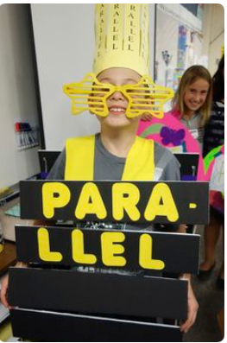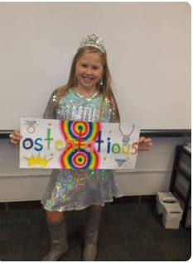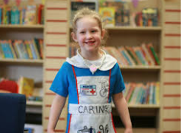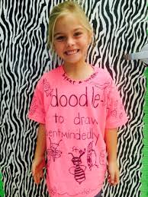
However, there will be prizes for the most creative outfits and we would encourage you to think outside of the box in order to introduce your child to new vocabulary. If you want to find alternative words wordhippo is a great online resource that can help. The staff will also be dressing up as a word and we will be allowing children to guess the staff word of the day.
Next Monday (2nd March) the children will bring an envelope home with a piece of paper in it. They need to bring it back to school with them on World Book Day with the word they have chosen to dress up as in the envelope and their own name on the front. These should be given to the teacher on World Book Day. This promises to be a very exciting and lovely day for the children in school and I would like to thank you in anticipation of your support with this event.
Many Thanks
Mrs Nuttall
English Subject Leader

