Key vocabulary
vertebrate | Animals that have a backbone. They can be divided into 5 groups: fish, amphibians, reptiles, birds and mammals.
fish | - cold-blooded  - scales covering its body  - has fins  - lives in water, lays eggs in water  - breathes through gills
amphibian | - cold-blooded  - start as eggs in water and breathe through gills  - later develop lungs and live on land and in water  - lays eggs in water  - damp skin/body
reptile | - cold-blooded  - breathes with lungs  - dry, scaly skin  - lay soft-shelled eggs on land
bird | - warm-blooded  - breathes with lungs  - lays eggs with hard shells  - covered with feathers  - have wings but not all can fly
mammal | - warm-blooded  - have fur or hairy skin  - give birth to live young  - feed their young milk
invertebrate | Animals that do not have a backbone. Can be divided into several groups including insects, spiders, snails and worms.
plants | Can make their own food. They can be divided broadly into two main groups: flowering plants and non-flowering plants.
Living things and their habitats – Year 6
Significant scientists
Carl Linnaeus  (1707-1778)  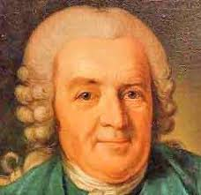 | Carl Linnaeus was a Swedish scientist who developed the modern system of classifying and naming organisms. Before this the names of living things were often very long. He gave them a two-part name.
Chris Nelson  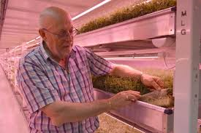 | Chris Nelson is a horticulturist and a director of Growing Underground which uses hydroponic techniques to grow pesticide-free crops in a former London underground air-raid shelter.
Classification
Living things can be classified into broad groups according to observable characteristics that are similar or different.

Micro-organisms
These are tiny living creatures. Most can only be seen through a microscope. They can be sub-divided into smaller groups including bacteria, fungi and viruses.

Flowering plants – numerous and diverse group. Reproduce through flowers and seeds. E.g. sunflower
Non-flowering plants – smaller group. They have a simple structure and do not have flowers or seeds. They reproduce through spores. E.g. algae, mosses

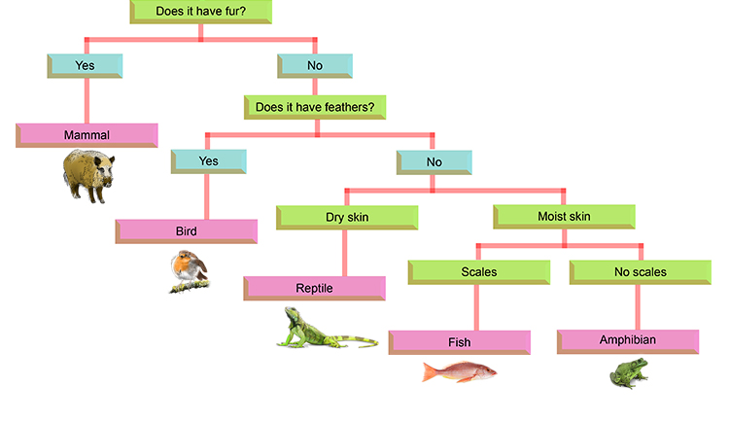
Classifying invertebrates
Classifying vertebrates
