Key vocabulary
sound | Something you can hear or that can be heard. We hear sound with our ears.
sound source | A source is producing sound when some part of it is vibrating.
vibrations | Sounds are made when something vibrates. This means it moves quickly backwards and forwards.
pitch | How high or low a sound is.
volume | How loud or quiet a sound is.
sound insulation | A material which blocks sound effectively.

How do we hear sound?
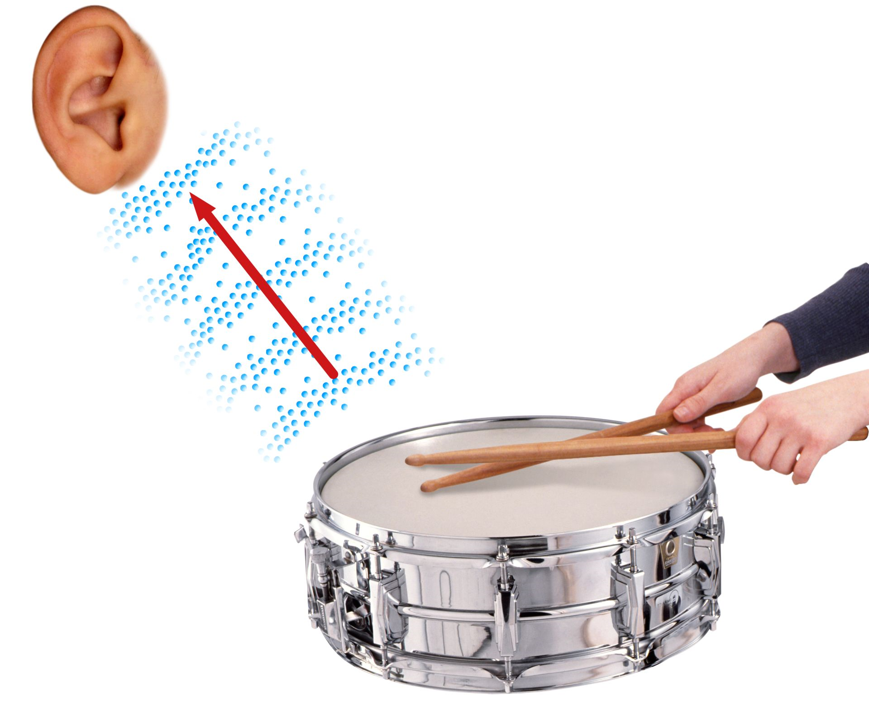
1. Banging the drum produces vibrations.
2. The sound travels through the air to our ears.
3. The vibrations cause parts of our body inside our ear to vibrate. This allows us to hear the sound.

Sound – Year 4
Significant scientist
Christian Doppler  (1803-1853)  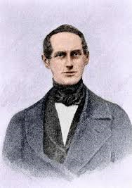 | Christian Doppler was an Austrian mathematician and physicist. He is celebrated for his principle known as the Doppler effect. This describes how noises sound different as you move toward or away from a noisy object.

As well as travelling through air (gas), sound can travel through solids and liquids:
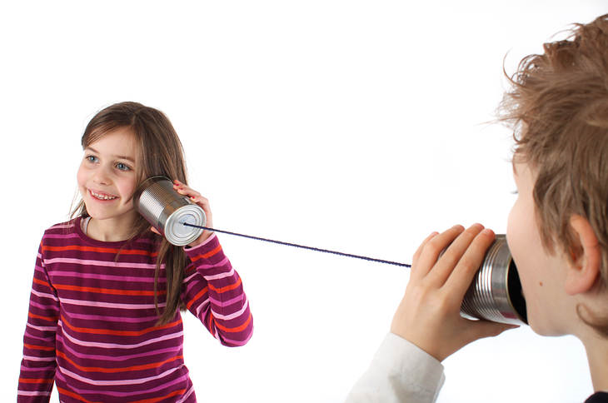 | 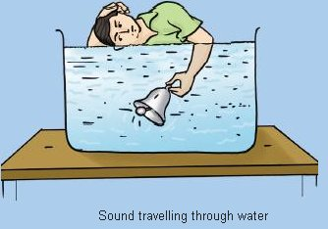

Pitch
The longer bars on the xylophone make a lower sound. | The shorter bars on the xylophone make higher sounds.

Volume
The volume (loudness) of a sound depends on the size of the vibrations.
If we blow an instrument harder, we make a louder sound.

The closer we are to the sound source the louder it will be.
A train arriving at a station sounds loud.

The further away from a sound the fainter it will be.
A train in the distance sounds quieter.

Insulating sound
We can wear ear defenders to protect our ears from very loud sounds.

