Key vocabulary
change of state | When a material changes from one state to another.
melting | A solid changing into a liquid.
freezing | When a liquid becomes cold enough to turn solid, it freezes.
melting point | The temperature at which a solid becomes a liquid.
boiling point | The temperature at which a liquid turns into a gas.
evaporation | When liquid changes into a gas.
condensation | The process when a gas changes into a liquid, caused by cooling.
water cycle | The never-ending process of water moving from the oceans, up into the atmosphere, and back to the Earth and oceans.
temperature | The measure of how hot or cold something is.

Solids, liquids and gases
A solid keeps its shape and has a fixed volume.
ice | 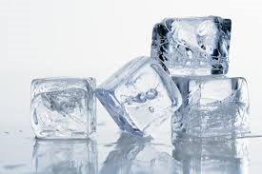 | sugar | 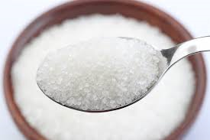
A liquid has a fixed volume but changes in shape to fit the container. It can be poured.
water | 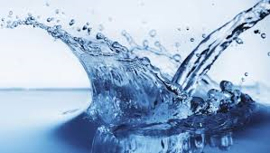 | honey | 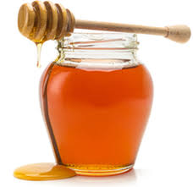
A gas fills all the available space; it has no fixed shape or volume.
water  vapour | 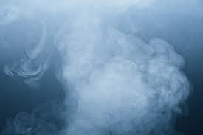 | bubbles in cola | 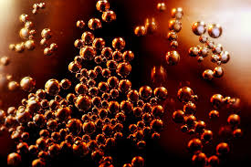
States of matter – Year 4
Significant scientist
Bernard Palissy  (1510-1590)  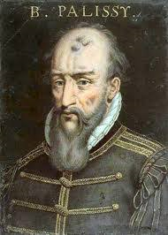 | Bernard Palissy was a French potter and scientist. He is often credited as the man who ‘discovered’ the modern theory of the water cycle. He asserted that rainfall alone was sufficient for the maintenance of rivers.

Melting and freezing
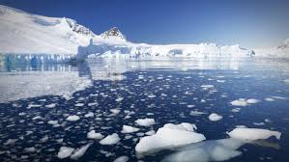 | Melting is a change of state from solid to liquid. The melting point of water is 0°C.
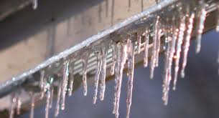 | Freezing is a change of state from liquid to solid. The freezing point of water is 0°C.
Boiling is a change of state from liquid to gas. Water boils when it is heated to 100°C. |  | 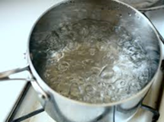

Evaporation and condensation
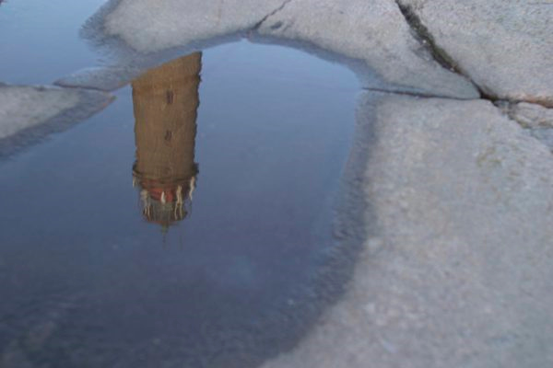 | Evaporating puddles  Evaporation is the change from a liquid to a gas at the surface of the liquid.
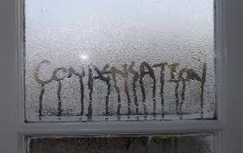 | Condensation in the bathroom  Condensation is the change from a gas to a liquid, caused by cooling.
The Water Cycle
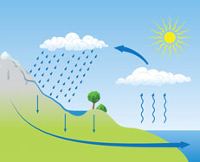
c
a
b
d
a | Water evaporates into the air  The sun heats up water at the surface of seas, rivers, lakes and turns it into water vapour. The water vapour rises into the air.
b | Water vapour condenses into clouds  Water vapour in the air cools and changes back into tiny drops of liquid water, forming clouds.
c | Water falls as rain snow, sleet etc  When too much water has condensed the water droplets in the clouds get too heavy and water falls back down to Earth in the form of rain, snow, sleet etc. This is called precipitation.
d | Water returns to the sea.  Rainwater runs over the land and collects in lakes or rivers which take it back to the sea.  The cycle starts all over again

