Materials and their uses
Material | Properties | Uses
wood | opaque  hard  strong | table  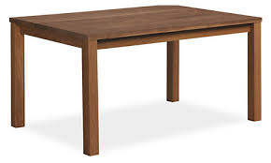
metal  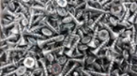 | shiny  smooth  reflective | fork  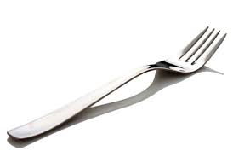
plastic  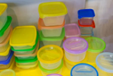 | waterproof  bendy  translucent | water bottle  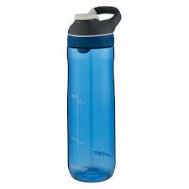
glass  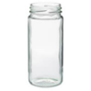 | transparent  waterpoof  hard | window  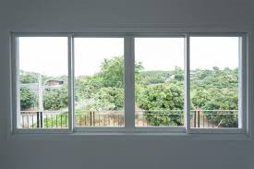
brick  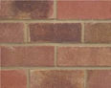 | hard  rough  dull | wall  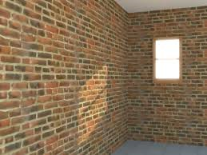
rock  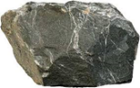 | strong  hard  rigid | fireplace  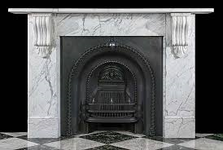
paper  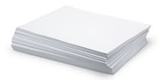 | tears easily  translucent  flexible | book  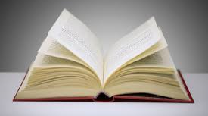
cardboard  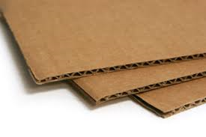 | dull  non-reflective  opaque | boxes  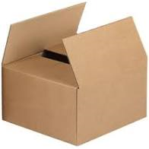
fabric  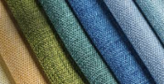 | flexible  Soft  absorbent | clothes  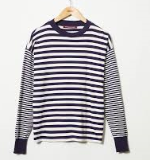
Uses of everyday materials – Year 2
Key vocabulary - properties of materials
transparent | Completely see-through
translucent | Let some light through but not completely see-through.
opaque | Not able to be seen through.
flexible | Bends easily without breaking.
rigid | Unable to bend or be forced out of shape.
reflective | Reflects light easily.
non-reflective | Does not reflect light.
absorbent | Able to soak up liquid easily.
Significant scientists
John Loudon McAdam  (1756-1836) | John Loudon McAdam was a Scottish engineer who modernised the way we build roads.  He was the inventor of tarmacadam road surfacing – commonly called tarmac.
Julie Brusaw | Julie is one of the inventors of Solar Roadways.  Solar roadways use solar powered road panels to form a smart roadway.
Changing materials
squashing
Clay can easily be pushed and pulled.
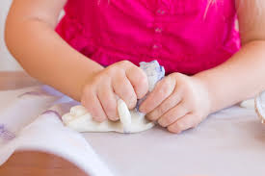
bending
Foil is bendy and waterproof.
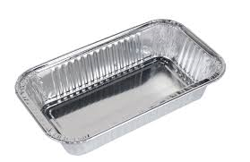
twisting
This plastic bottle’s shape can be changed.
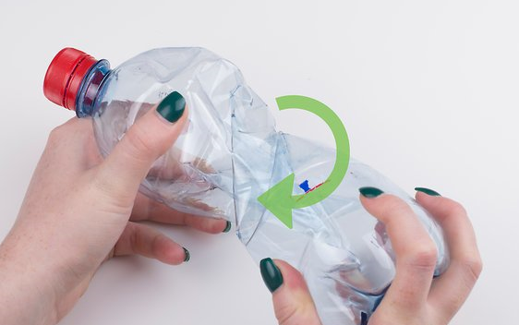
stretching
A balloon is very flexible.
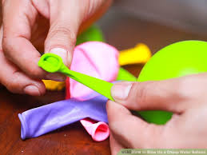
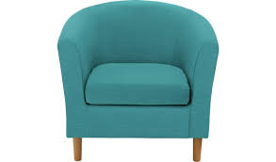
This chair has a fabric seat because it is soft.
It has wooden legs that are rigid and strong.

